1. FAMILY

1.A.
- definition
- in general – kinds of families (nuclear, extended, step parents, adopted, single-parent, divorced, separated) children’s houses
- my family - in general – briefly
(mother, father, siblings, grandparents, cousins, aunts, uncles)
- Mother – appearance (zovňajšok), age, job, qualities, likes, dislikes
- good parent x good child
- holidays in my family
- weekdays, weekends
- duties
- best memories
- problems in families
- (generation gaps, money, alcohol, drugs, arguments, divorces (rozvody), unfaithfulness (nevernosť))
- families in SR, USA, VB
- my ideal family

1.B. my biography
- birth, créches, kindergarten
learning, activities
- my first day at school – subjects, teachers, trips, memories, hobbies
- Grammar – differences
- The Ribbon party
- My future plans - study, family, house
- My favourite – music, person, food, subject, book, film, magazine
season, holidays
- Aká som osobnosť? moje vlastnosti, dôležité miesta pre mňa, čo ma nahnevá, cestovanie, šaty ktoré rada nosím, športy, či viem variť, čo robím pre zdravie, masmédia – čo pozerám, či rada nakupujem, či chodím k starkým

2. CULTURE AND THE ARTS

- Definition
- Functions of the art
- kinds – decorative, performing

- music – kinds of music
- musical instruments, jobs- drummer, flutist...
I & music
my favourite group, song, composers
my family & music
my schoolmates and music
dance – kinds
where – disco, home, group
I & dance, family & dance, dance in our class
film – kinds, programmes, where I watch films, what, I like , where is the nearest cinema
theatre – where I go to the cinema, the plays I remember
dvd – versus theatre, cinema ,video
Fine arts- painters, famous paintings, my attitude towards the painting
Architecture – what is modern now
Literature- kinds, reading material, what I read, what we read art school
DIFFERENT AGE GROUPS AND ARTS- children, teens, adults, older people
Arts in the past/ now- comparison
town & village – cultural possibilities in a town and village
- cultural life in our village/town
performance with my schoolmates – theatre, exibitions, trips- Paris- Louvre, English performance, Jánošík, Rysavá jalovica, Reštavrácia...
Cultural life in Slovakia – festivals like Pohoda, rock fest, folk groups and festivals- Východná, Terchová
Slovak , English & American stars – singer, actors, writers, - past, now

3. SPORTS and GAMES


- definitions- sports, games
- importance of practising a sport, benefit of sports
- kinds of sports- summer, winter, indoor, outdoor, ball, water, extreme, individual, collective
- equipment for practising some sports
- places of practising a sport /game
- AGE GROUPS- children, teens, adults, older
- characteristics of a good sportsman/fan
- My attitude to sport- what, when, who with, how often, why, what I need
- PE lessons at school- what games, sports,
- Sports facilities in my town/ village, region - Marína park, football stadium, hockey stadium, fitness centre, gyms, swimming pool...
- Sports channels, programmes on TV
- Favourite sports/games in SK, GB, USA
- Competitions, matches, the Olympic games- symbols- flag, creed, frequency, fire
- Dangers in sport
- Sports/ games I would like to try one day
- Famous sportsmen/women, clubs, teams in the world

4. HOUSING & HOME

- MY HOME 1– definition, my town – history (short)
- people, river, buildings – historical: church, town hall, museum, cultural: cultural house, open-air-theatre, shops: grocers, bakers, .., special: hospital, police station, post office, town office, district office (okres), banks, susurance companies, charity, pensioner´s house
- sport in my town – hockey stadium, football stadium, tennis court, Marina park, ski lift, lake, fitness centre, gyms, ice rink(umelé klzisko)
- nature – river, woods- lifts, lakes, Zamčisko, Thurzov, Majales, Gloriet-view, Cechy
- transport in my town
- people – the Gypsies
- difference - village x town
- problems
I miss .. (čo mi chýba)

- MY HOME 2 – my home / flat
- activities
- rooms + objects – there is / there are
- compare house and flat – adv. + disadvantages
- my ideal home
- types of houses
- living generally – old, poor, homeless, young, students

5. SHOPPING & SERVICES

- shopping habits in the past or at present
- costumer society, shopaholics
- shopping – market, local shop, supermarket
- list of shops generally and in GL
- shopping in the family (who, why, when, how often, where, what)
- what I do buy everyday /once a week/
- my favourite shops /why/
- relationship customer – shop assistant
- shopping at the grocer’s – describe
- shops and there goods (tovar)
- shopping in the village / city
- Christmas shopping and Easter– in general my family
- modern society and services – banks, offices, hairdresser´s, beautician, petrol
station, cleaner´s
- services in GL
- services used by our family
- modern ways of shopping and paying (Internet, catalogues, accounts, card,
mortgage, instalments).

6. HEALTH CARE

- human body- its parts, importance of some organs
- diseases: common, serious, latest
- injuries and accidents in everyday life
-Common diseases of different age groups, countries
- healthy lifestyle: diet, exercise, sports, relaxation, positive attitude to life
- influence of heredity (dedičnosť), environment, weather
- bad habits – junk food , laziness, sedentary work, smoking, alcohol, drugs, work stress
- visit at the doctor / dentist - procedure
- value of health
- my health – children’s, now
- injuries
- jobs – a doctor, nurse, ambulance drivers
- Health care in Slovakia

7. TRAVEL

- in general – who, why, where
- advantages and disadvantages of each kind of transport
- my traveling
- traveling in my family / town / region
- town / village
- my best trip / worst
- my summer holidays 2007

8. EDUCATION

- definition, importance
- school system in Slovakia
- types of school – attendance, school year, holidays, subjects, teachers, building,
class, trip, homework, tests, after school activities
- Teaching methods, testing, exams, modern ways of teaching
- Students´ life- time at school and after school
- my schools, schoolmates, relations between students and teachers
-opinion on learning foreign languages, exchange stays, language courses, au- pairs
- British school system – stages, lessons, holidays, uniforms, exams, universities

9. JOBS AND PROFESSIONS

- why we work, benefit
- kinds of jobs (manual, intellectual)
- indoor x outdoor
- well-paid / less-paid , popular jobs at present
- teachers, doctors, workers – advantages / disadvantages
- choosing a job – children, youngsters, adult
- influence and criteria of choosing a job- job centres, application form, CV,
retraining, job interview
- preparation for a job – schools, courses
- job interview – questions asked
- Working time and free time in the lives of people in big cities and small villages
- working opportunities in Slovakia and abroad, working conditions (payment,
social system)
- family life and a career- difficulties, positives
- problems at work – bullying, salary, unemployment
- my future job – childhood - now
- experience with some job - seasonal job
- the jobs of my relatives, parents

10. RELATIONS

- importance, reasons for meeting people
- positive and negative relations
- formal/ informal relations
- family relations
- friendship, values you appreciate on your friends
- partnership, love, marriage
- penpals, social network friends
- neighbours, colleagues
- relations between students and teachers, T and S, among students
- problems in relations- divorces, quarrels, bullying, violence, rasism, indifference, generation gaps, attitude to handicapped, murders, sexual abuse
- solutions of the problems with relations
- traits of an ideal husband, friend

11. NATURE

- definition weather, climate
- course of the year- 4 seasons with their characteristic features, changes in
nature, activities, clothes
- flora and fauna, wild animals, domestic, pets, ZOO animals, protected animals
- Ecological problems in the world- the ozone hole, acid rain, global warming,
deforestation, pollution of air, water, land
- natural disasters- earthquakes, hurricans, floods, tsunami, their effect on people´s lives
- ecology, environment , protection of the nature - solutions

12. SCIENCE

- life nowadays and in the past
- The most important inventions of humankind
- domestic appliances
- computers at work and for entertainment
- Misuse of science and technology – addictions, weapons, consumer society

13. MAN AND SOCIETY

- society- definition, reason for groping people
- rules in society- street, family, school, laws
-punishment for breaking the rules
- behavior of youngsters and older people
- meeting and visiting people- etiquette, time, reasons, topics for discussions
- moral rules and laws at various places (home, school, church, street)
- charities, sponsoring, help to people in need
- family in 21 st century- changes, new phenomena

14. COMMUNICATION and its forms

- definition
- kinds of c. - verbal - languages
- non verbal - writing, mimics, gestures, body language
- com. of animals
- modern types of c. – phone, e-mail, internet, sms, social networking sites
- com. in danger
- learning languages-reasons, difficulties, use, advantages comparison of
languages
- formal & informal language
Standard and non standard form of language- dialects, slang
- my favourite kinds of communication
- age groups

15. MASS MEDIA

- definition, functions
- influence of massmedia on family, society, individuals- both positive and
negative
- kinds of m. - TV, radio, press, newspapers, magazines, Internet
- what can you find in newspaper, magazines, on TV
- advantages and disadvantages of each kind of m.
TV channels, TV programmes, radio stations – famous –
- using of Internet and its positives and negatives for humans –home, work, school, payment, shopping, films, music, e-mails, chats, foreign languages
- age groups and media
- quality x gutter press
- mass media x me
- massmedia and my family
- mass media in SK, GB, USA

16. YOUNG PEOPLE and their world

- definition
- division – teenagers, adults
- looks, activities, behavior, thinking, places, language, friends, idols, dislikes
- looks – clothes, make-up, duties, hobbies
- groups – positive + , negative –
- adults x teenagers
- problems of young people – school, love, friendship, parents, money
- plans to the future
- me as a young person
- my childhood and now
- me x adults x older people
- youth now and 20 years ago (jobs, study, hobbies, travelling)
- youth in my town / SK

17. FOOD

- reason and value of eating
- kinds of meals (meat, dairy products, fruit, vegetables, drinks)
- eating habits of children, teens, adults and the old
- eating in a restaurant x at home x at the canteen
- my eating habits (likes, dislikes, main meals)
- eating in my family – everyday eating, weekends
- fast food, picnics, take – away meals
- Slovak national food and drinks
- healthy x unhealthy diet
- vegetarians x vegans
- my favourite eating place
- problems of eating – diseases, overweight, sweets, …
- national meals in the world

18. INTERESTS & LEISURE I., II.

- definition – free time
- free time now and in the past, in the future
- in general – kinds of hobbies (sport, music, arts, fun, TV watching, housework, pets, hand work, reading, ..)
- different age groups – children, teens, adults, older
- my hobbies from childhood up to now
- hobbies in my family / after school activities
- my weekdays and weekends,
- lifestyle of my relatives
- similarities and differences of people aged 10, 20 and 40 concerning free time
- my ideal day / weekend
- problems of free time – TV, drugs, alcohol
- free time in GB, USA, SK

19. MULTICULTURAL SOCIETY

- definition
- assimilation, xenophobia, rasism,
- division of people – skin, races, religions, social groups, customs and traditions, nationalities, continents
- cosmopolitan cities , countries– definition, examples
- Slovakia - nationalities, emigrants, immigrants, Vienamese, Romanies, the Ukraines
- problems – bullying (násilnícky), religious problems – Northern Ireland, Islam- terrorism, skinheads, fasism,
- benefits of the multicultural society (úžitok)
- situation in our region, town, school
- mixed marriages – advantages, disadvantages
- cultural exchanges
- languages – comparison
- Future of MCS
- holidays and customs in SR – Christmas, Easter, New Year’s Day, Fasiangy, Lent, All Saints´Day
- holidays in Great Britain- and the U.S.A.- Halloween, Valentine´s Day

20. TOWNS & PLACES

- in general village x town + -
- famous places
- unknown places
- birthplace
- my home town / village
- place of study (work)
- holiday destination
- my dream home / holidays
- places I have visited
- my favourite places

21. FASHION

- definition, importance(dôležitosť)
- men’s and women’s clothes
- clothing in the past and at present
- clothing generally (children, adults, old, teens)
- clothing in hot and cold counties
- fashion and weather (rainy – boots, umbrella, ..)
- uniforms – jobs
- clothing at work, sport, party, out, disco, school, bed
- my clothing (school, out, disco, party, the Ribbon party)
- accessories (príslušenstvo)
- colors – kinds, symbol
- my favourite clothes, colors
- fashion designers, shops
- national costumes – when, who
- people in my family
- latest fashion

22. THE BOOK – a PERSON´S FRIEND

- definition, short history of books
- reading material
- reading in general (children, teenagers, adults, the old)
- reading in my family
- reading at school (compulsory, voluntary)
- my favourite reading material (book, magazine, newspaper)
- the contents of one book
- my favourite writers, famous writers
- Slovak, British and American press
- Benefits of reading (úžitok)
- Reading places (bookshops, libraries)

23. EXAMPLES & IDEALS
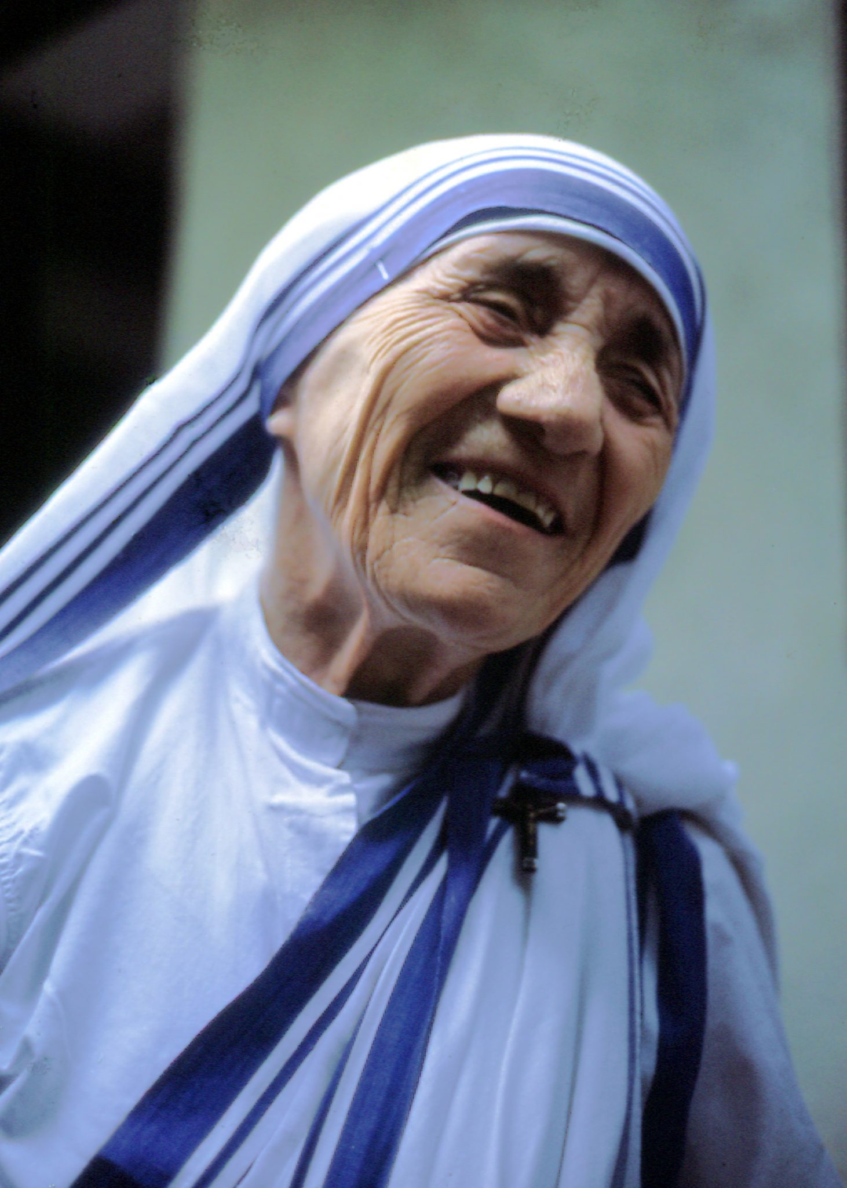
- Definition
- Positive characteristics of an idol
- Reasons for having an idol
- qualities – positive, negative
- ideal man/woman nowadays
- AGE GROUPS- children, teens, adults, older people
- heroes, pop-stars, celebrities
- positive and negative influence of an idol
- heroes in everyday life – jobs – firemen, doctors, astronauts, soldiers, policemen
- organizations – charity, the Red Cross, Greenpeace, UNICEF
- celebrities and persons and their influence on society: the Mojsejs, Superstars, Pope John Paul 2, Mother Theresa
- MY IDOL- in details
- compare yourself and your idol
- my idols – history
- idols in my family, class, Slovakia, USA
- Am I an idol for anyone? How
- Heroes in some countries
- Behaviour of people in crisis situations

24. THE COUNTRIES WHOSE LANGUAGES I AM LEARNING

25. SLOVAKIA – MY HOMELAND

- definition, position, area, neighbors, density (hustota), edges (hranice)
- population - nationalities
- language, religion, climate, national symbols – flag, anthem, emblem
- nature – flora, fauna, rivers, mountains, spas, caves, dams, lowlands, national park
- historical sights – castles, churches
- politics – government, the President
- history – 833, 863, 1948-49, 1918, 1939, 1992, 1993
- famous people – in the past x now - music, literature, politics
- organizations – EU, NATO, Vishegrad 4, currency 2009 – Euro
- Slovak people – characteristics
- typical Slovak – food, costume, sport, drink, industry, natural resources
- transport
- problems
- customs and traditions
- national holidays

